5.44: This is the same situation as Example 5.23. Solving for 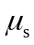 yields
